Output from Model 1 Gibbs sampler – Regression model with covariates being the scaled versions of area and temp

Posterior Mean for Beta:

[1] 5.7683306 0.1870397 0.0629471

Posterior Mean for s2:

[1] 0.05142897

Dhat: -46.46542 Davg: -44.07088 pD: 2.394541 DIC: -41.67634

RMSE: 0.09623655

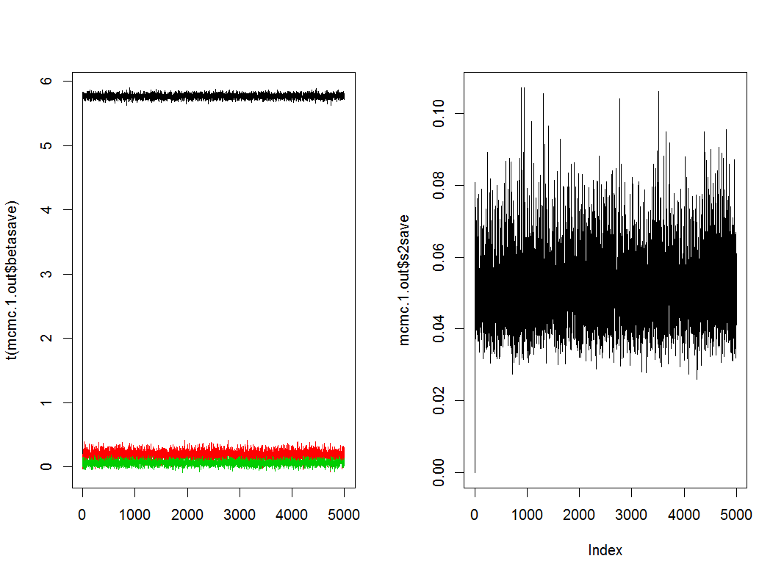

Output from Model 1 Gibbs sampler – Regression model with covariates being the scaled versions of precip and temp

Posterior Mean for Beta:

[1] 5.7444838 -0.1040967 0.1303773

Posterior Mean for s2:

[1] 0.05206233

Dhat: -45.22245 Davg: -42.85153 pD: 2.370918 DIC: -40.48061

RMSE: 0.1012098

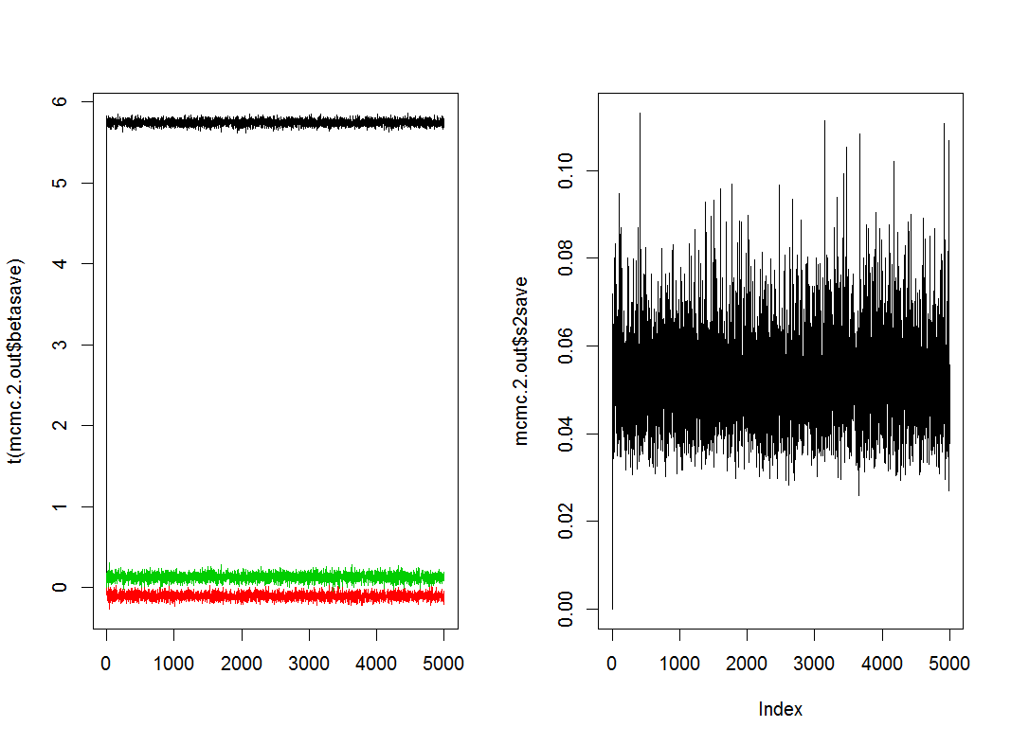

Output from Model 1 with Metropolis-Hastings – Regression model with covariates being the scaled versions of area and temp

Posterior Mean for Beta:

[1] 5.76884330 0.18834731 0.06276272

Posterior Mean for s2:

[1] 0.01062337

Dhat: -89.60333 Davg: -85.46997 pD: 4.133363 DIC: -81.33661

RMSE: 0.09676636

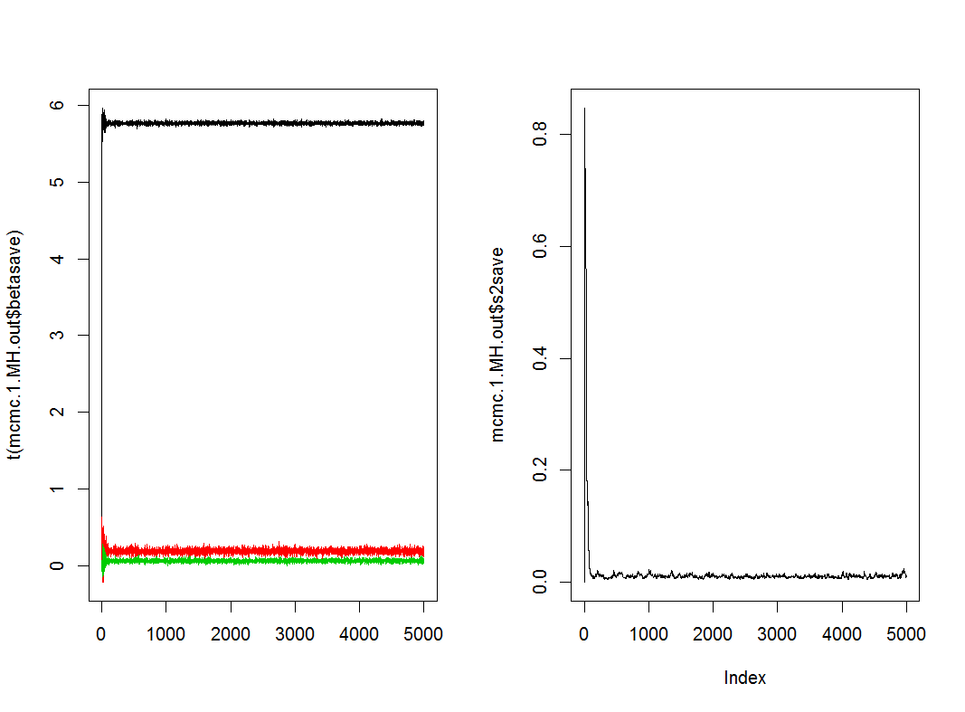

The DIC’s are very different probably because of different priors. BUT do not choose priors based on DICs!!

Challenge: Change the s2sd from 100 to 0.1

First Model but with s2sd set to 0.1 instead of 100:

Posterior Mean for Beta:

[1] 5.76635959 0.18826918 0.05797215

Posterior Mean for s2:

[1] 0.8158269

Dhat: 80.64371 Davg: 83.49385 pD: 2.850135 DIC: 86.34398

RMSE: 0.09285818

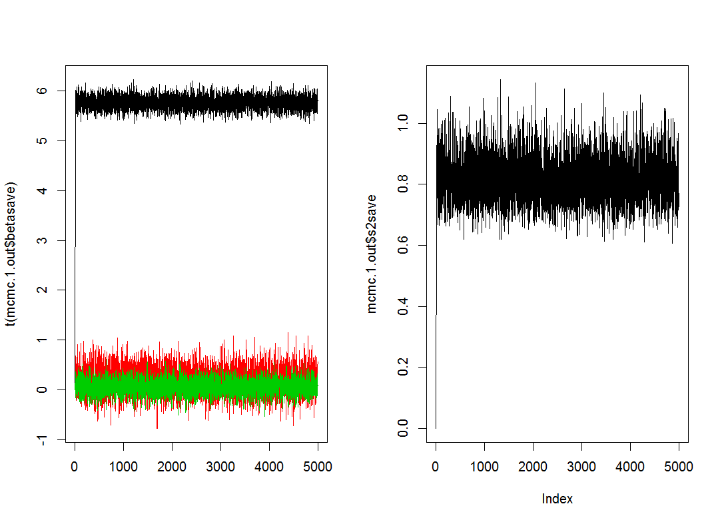

First Model but with s2sd set to 0.01:

Posterior Mean for Beta:

[1] 5.76630724 0.18113330 0.06626769

Posterior Mean for s2:

[1] 0.9975947

Dhat: 90.39716 Davg: 93.44876 pD: 3.051596 DIC: 96.50036

RMSE: 0.0978226

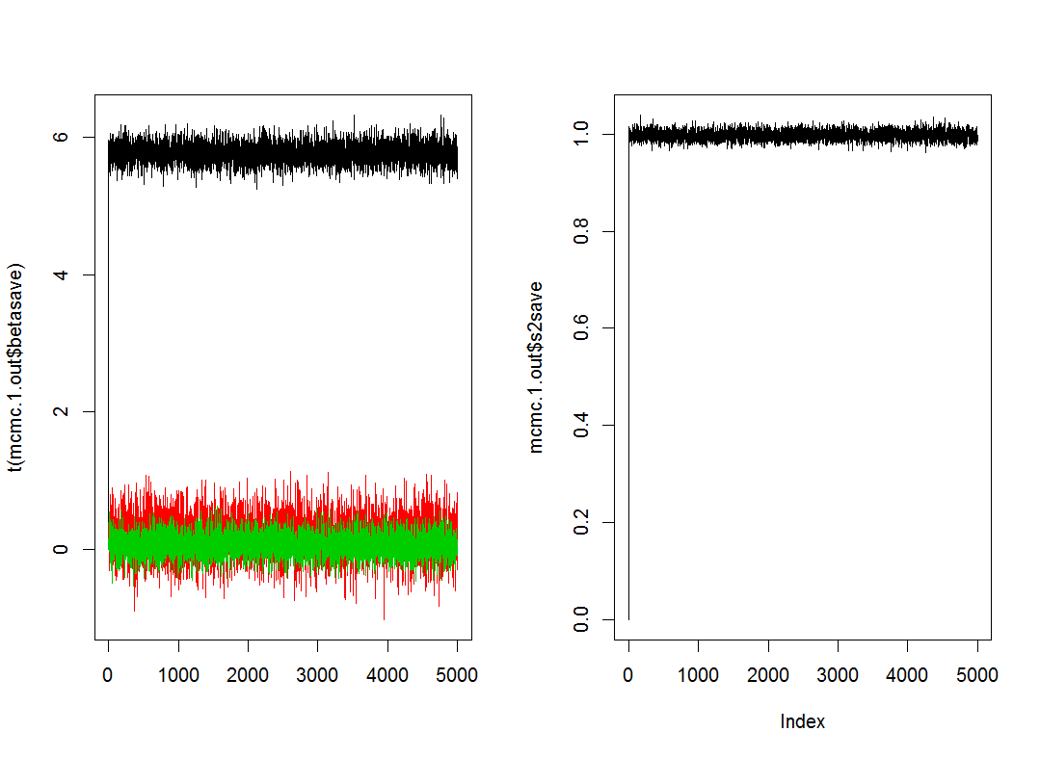

So the model is very sensitive to the setting for this prior – changing the sigma^2 results in very different results.

Should play with tuning parameter\*\*\*